**In-Person Presentation and Poster Details**

Spoken presentations at ST&D 2025 are in **20-minute slots**. Each **presentation** will last **15 minutes**, followed by **5 minutes of questions and answers** (Q&A).

A laptop and projector will be available in each room.

Speakers will be asked to **bring their presentation on a USB drive** a few minutes **before their session**, to upload it to the laptop available in each room. There are no restrictions on the presentation file format (e.g., PowerPoint). Still, we strongly recommend bringing a PDF version to ensure compatibility across all devices in case of technical issues.

## **In-Person Poster Details**

In-person poster presentations at ST&D 2025 are scheduled in **1-hour and 30-minute time slots**.

We suggest that your poster include the title and authors, research aims or questions, a concise method section (sample, design, materials, and procedure), key results (preferably with graphs and supporting statistics), and main conclusions with relevant implications. To enhance clarity, we recommend including examples of stimuli and highlighting contrasts between experimental conditions. Posters should be **as self-explanatory as possible**, allowing you to focus on answering questions.

Posters can be left at the help desk and may be **set up in the assigned rooms** during the coffee break **immediately preceding the poster session**. Presenters will be asked to remove their posters at the end of the session.

Posters should be printed in **portrait orientation** (see fig. below), with a maximum size of ISO A0 to fit the display boards (84.1 cm wide × 118.9 cm height / 33.1 × 46.8 inches). There are no restrictions on the materials (e.g., glossy paper, matte paper). Boards and poster clips will be provided.

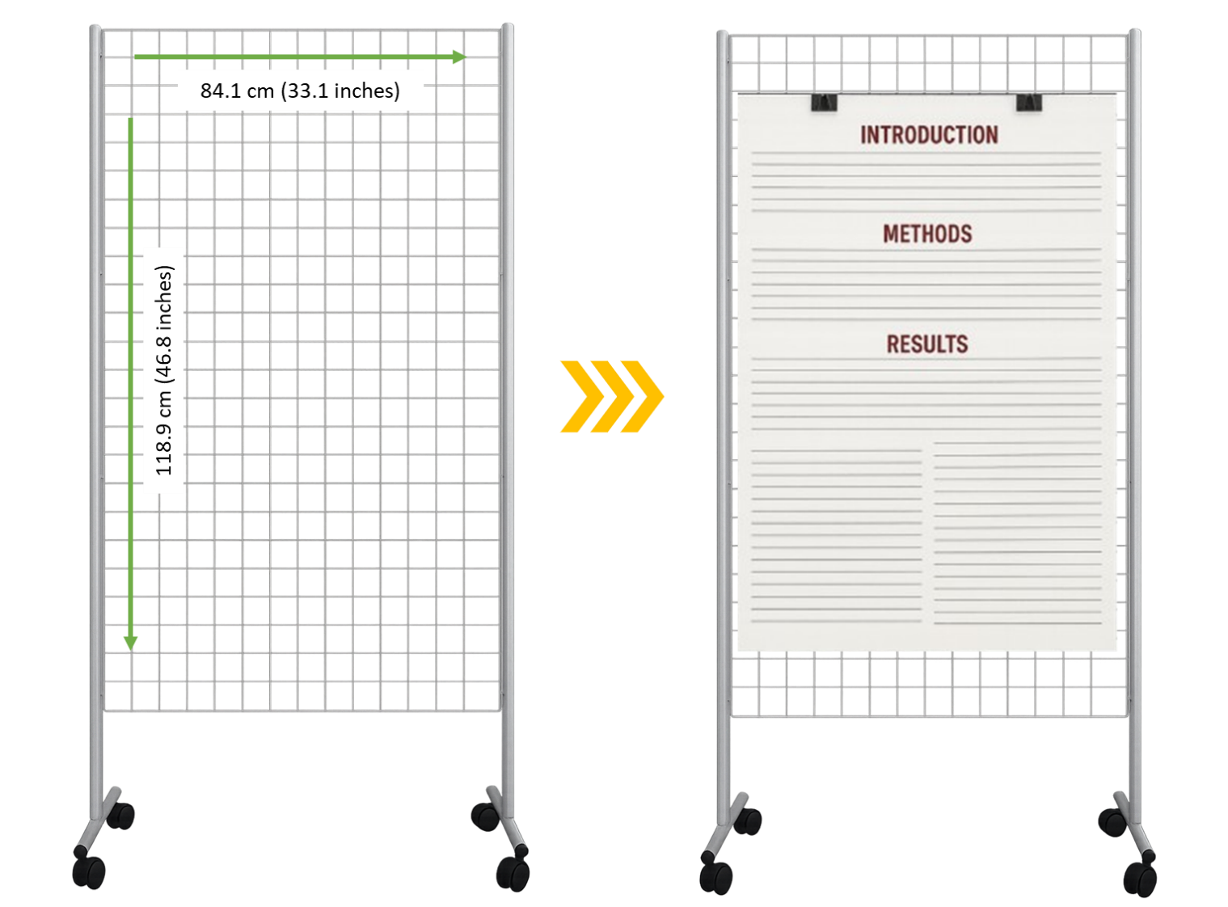

**Where to Print Your Poster Nearby**

For your convenience, we have listed some copy shops located near the university area where the conference will take place.

Please note that we do not have any formal agreements with these providers; this information is shared solely to assist participants who may need to print posters or other materials during their stay.

**La Plotteria**   
📍 Address: Via del Portello, 14, 35129  
📞 Phone: +39 049 202 0750  
✉️ Email: info@laplotteria.it  
🌐 Website: <https://laplotteria.it/>

**Studio 145**   
📍 Address Via del Portello, 3, 35129  
📞 Phone: +39 049 775619  
✉️ Email: studio145padova@gmail.com  
🌐 Website: <https://www.facebook.com/p/Studio145-100063457572894/>

**Centro Copia Stecchini**   
📍 Address: Via Tommaseo, 108 Padova, 35131  
📞 Phone: +39 049 74 02508  
✉️ Email: ccs3@centrocopiastecchini.it  
🌐 Website: <https://www.centrocopiastecchini.it/>

**Copisteria All'Angolo**   
📍 Address: Via del Portello, 97, 35131   
📞 Phone: +39 351 846 4160  
✉️ Email: copivendolo@gmail.com  
🌐 Website: <https://www.copisteriaallangolo.it/>

## Internet**Remote Presentations and Remote Attendance**

**Asynchronous remote** presentations will be hosted remotely.

Remote poster presenters are asked to **upload a short elevator pitch video** of their poster **by July 7**. The upload link will be sent directly to presenters via email. If you do not receive these instructions or would like them sent again, please contact std2025@easychair.org.