AGENDA & Minutes

2022 Business Meeting for the Society for Text & Discourse
July 21, 2022, 3:15-4:15 PM ET
Zoom link: https://siena.zoom.us/j/91678379529
PowerPoint: https://bit.ly/2022std-meeting-ppt

- Call to Order (Joe Magliano)

Members present: n = 45

- Action item: Approval of the 2021 Business Meeting Minutes (Mike Mensink)
  - Motion: Kate Bohn-Gettler
  - Second: Alexia Galati
  - Discussion: None
  - Vote: Unanimous

- Book drawing # 1: Sarit Barzilai

- Changes in Governing Board (Joe Magliano)
  - Welcome new members
    - Sarah Carlson (Governing Board, 2022-2028)
    - Jennifer Wiley (Governing Board, 2022-2028)
    - Scott Hinze (Secretary, 2022-2025)

  - Recognition of departing members
    - Jason Braasch (Governing Board, 2016-2022)
    - Chantel Prat (Governing Board, 2016-2022)
    - Kate Bohn-Gettler (Governing Board, 2020-2022) - stepping down early.
      - A special election will be called immediately after the 2022 conference pending our bylaw changes for Kate’s remaining term (2022-2026).
      - The elected individual will begin service on the GB immediately.
    - Mike Mensink is stepping down as Secretary (2017-2022)

- Treasurer’s Report (Emily Smith)
  - To review: 2022 ST&D Treasurer’s Report

- Secretary’s Report (Mike Mensink)
  - To review: 2022 ST&D Secretary’s Report
  - Announcement of the new website: https://www.societyfortextanddiscourse.org/

- Discourse Processes Report (Catherine Bohn-Gettler & Johanna Kaakinen)
- 2021 Impact Factor: 2.44
- 6-year Impact Factor: 2.67
- 52,000 downloads so far this year.
  - Submit to, read, and cite Discourse Processes to support the journal
- New DP blog on website: www.societyfortextanddiscourse.org/discourse-processes
- Open access available for special issue through August
- ST&D members are encouraged to submit ideas for special issues and/or forums (themed issues)
- Agenda for next year:
  - Increasing access/visibility with Open access and green access
  - Blog posts coming, with commenting and option for writing new posts
  - Engagement via social media
  - Encouraging level 2 open science practices
  - Encouraging replication studies and registered reports.
  - Equity mission:
    - Gold open access for equity award papers.
    - Spotlight on equity label for relevant papers (including commentaries)

- 2022 Meeting Report
  - Total submissions = 107
    - 3 keynotes
    - 2 symposia
    - 2 roundtables

  - Joe Magliano expressed the

  - Registrations = 174 (updated July 21, 2022)
    - Regular members = 79
    - Student members = 47
    - Nonmembers = 12
    - Student nonmembers = 25
    - Special guests = 11

  - 2022 Special DP Conference Issue editors:
    - Daphne Greenberg (Lead)
    - Jason Braasch
    - Liz Tighe

  - Thanks to student volunteers (Ness, Dahl, Martinez, Clark, Troemmel)

- Future Meetings
  - 2023 - Oslo, Norway (June 28-30, 2023)
    - Ivar Braten & Helge Stromso (Chairs)

  - 2024 - Chicago, USA (July)
    - Anne Britt, Jenny Wiley, & Mike Wolfe (Chairs)

  - 2025 - North America location
    - Seattle?
    - Pittsburgh?
    - Minneapolis?

  - 2026 - Europe or other non-NA location
    - Italy?
    - Netherlands?
    - Germany?

- Committee Reports (as available)
  - Representation, Inclusion, and Outreach
    - Diversity statement
    - DEI Travel Award

- Bylaw Discussion & Vote (Mike Wolfe)
  - 2021-2022 Bylaw Committee: Mike Wolfe (Chair), Kate Bohn-Gettler, Kate Cain, Scott Hinze, Joe Magliano, Mike Mensink, Gale Sinatra, & Emily Smith

  - To review: 2022 Proposed Bylaw Changes
    - Current ST&D Bylaws
      - In effect until end of 2022 business meeting
    - Master bylaw change document
      - Notes from our work in 2022 for future committees
    - Proposed bylaw changes were unanimously approved for a final membership vote by the Governing Board on July 12, 2022.

  - Rationale of changes:
    - Legal requirements from the Societies Consortium on Sexual Harassment in STEMM, as well as IRS requirements to become a 501c3 organization.
    - Unclear and outdated processes and gendered language.
    - Necessary to enact inclusive policies and procedures.

  - Summary of changes:
    - Article I: Name and Object
      - Drop ‘Incorporated’ from our name.
      - Add non-profit organizational definition as recommended by our legal advisors.
    - Article II: Membership
      - Update procedures and removal of gendered language.
      - Authorize the establishment and communication of official policies.
      - Enable enforcement of policies by the Governing Board.
    - Article V: Elections
      - Update procedures to reflect current practices (i.e., online/email)
      - Specify the duties of the Secretary to conduct the election.
      - Empower the Chair and Governing Board to call a timely election in the event of resignation/death/recall of a GB member.

  - Notes about Robert’s Rules & Discussions:
    - We cannot discuss the bylaw changes until a motion is on the table.
    - Please use the ‘raise hand’ zoom feature during discussion.
    - Friendly amendments would require another vote by the Governing Board

  - Action item: Motion to approve changes to the ST&D Bylaws for Article I: Name and Object, Article II: Membership, and Article V: Elections.
    - Motion: Kate Bohn-Gettler
    - Second: Katie McCarthy
    - Discussion:
- Question from Susan Goldman regarding emeritus members voting. Mike Mensink noted that all “levels” of membership fall under one type of membership (we only have members and student members). Susan suggests additional specification regarding levels and voting status, including student voting.
  - Clarification was provided that all members can vote, including students. SG: these are ambiguities that could be clarified by committee
  - Danielle McNamara: recommended labelling different costs rather than levels for clarity.

    - Vote:
      - Voting link: https://forms.gle/6YXgmcwHwazuvCMa6
        - By participating in this vote, you are affirming that you are currently an active member or student member of the Society for Text and Discourse.
      - 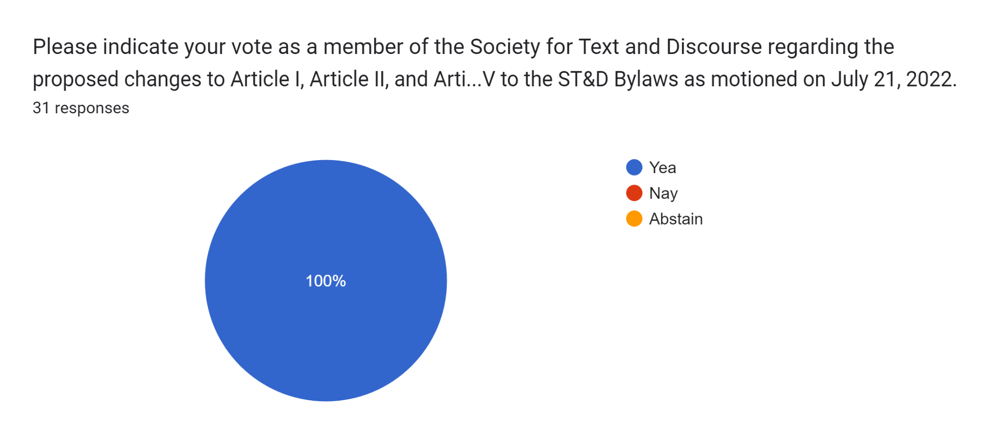
      - Yay: 31, Nay: 0, Abstain: 0

- Review 2022-2023 ST&D Committees & Special Election (Joe Magliano)
  - Committee assignments for review
    - 2022-2023 ST&D Committees
  - Special Governing Board election
    - With the passing of the bylaw changes, we will call a special election for a replacement Governing Board member to serve a 2022-2026 term.
    - The replacement Governing Board member shall begin their term immediately following the conclusion of the election.
    - Details will be emailed to the membership soon.
    - We welcome self-nominations for the special election!

- Open floor for concerns or discussion from the membership (Joe Magliano)
  - No concerns or discussion

- Adjournment

